2021 Ellsworth County

***Open Class Fair***

***July 19- July 22, 2021***

***Exhibits: Ellsworth Armory***

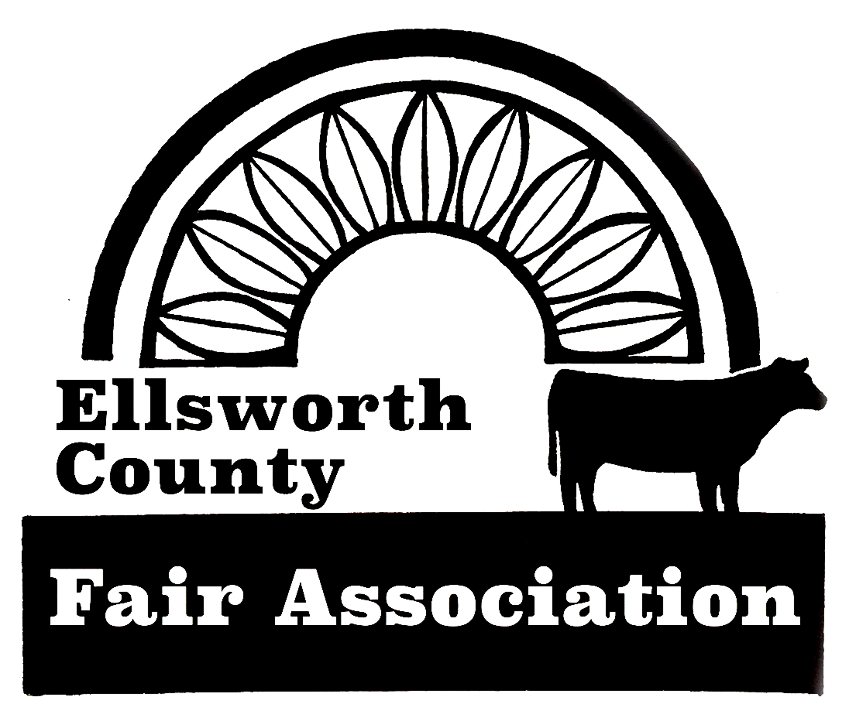

**Table of Contents**

**Page No.**

**Fair Superintendents 2**

**Special Prizes 3**

**Schedule of Events 4**

**Open Class Fair General Rules 4-5**

**Divisions (Check each division for specific rules.)**

**A - Foods 6-9**

**B - Food Preservation 9-11**

**C - Wearing Apparel 12**

**D – Needlework …………………………………………………………. 13-17**

**E – Horticulture ……………………………………………………….. 18-19**

**F - Crops 20**

**G - Arts & Crafts ………………………………………………………...21-22**

**H - Woodworking 23**

**I – Floriculture ………………………………………………………….. 24-25**

**J – Photography ………………………………………………………….26-27**

**K - Tag-Along Livestock ……………………………………………….. 28-30**

**L - Agricultural/Industrial Technology ………………………………. 31-32**

**Sample Entry Tag 33**

**Livestock Judging Contest ……………………………………………….. 34**

**Youth Scavenger Hunt 35**

**Youth Local Conservation Photo Contest ……………………………… 36-37**

***K-State Research & Extension is an equal opportunity provider & employer.***

**Open Class Fair Superintendents**

**Help is needed for ALL Divisions of the Open Class Fair. To volunteer, contact the Ellsworth County Extension Office at 785-472-4442.**

Foods

Food Preservation

Wearing Apparel

Needlework

Horticulture

Crops

Arts & Crafts

Woodworking

Floriculture

Photography

Tag-Along Livestock Travis Janssen – Chair

Delane Janssen

Clayton Huseman

Sharla Huseman

Katie Kueser

Ag/Industrial Technology Karl Dawn Stover

Livestock Judging Karl Dawn Stover

**Open Class Special Prizes**

**The judge will designate whether the Junior or Senior champion is to receive the Special Prize offered in that Division unless both prizes are offered.**

**Best of Show and special prizes**

Division A: Foods Exhibit Sweepstakes

Division A: Foods Exhibit, Junior

Division A: Foods Exhibit, Senior

Division B: Food Preservation

Division C: Clothing Exhibit

Division D: Needlework Exhibit

Division D: Quilt Exhibit

Division D: Friendly Neighbors FCE Favorite Exhibit

Division E: Horticulture Exhibit, Junior

Division E: Horticulture Exhibit, Senior

Division E: Biggest Contest

Division F: Crops Exhibit

Division G: Arts Exhibit, Junior

Division G: Arts Exhibit, Senior

Division G: Crafts Exhibit, Junior

Division G: Crafts Exhibit, Senior

Division H: Woodworking Exhibit

Division I: Floriculture Exhibit, Junior

Division I: Floriculture Exhibit, Senior

Division I: Floriculture Dried/Silk/Artificial Arrangement

Division J: Photography Sweepstakes

Division J: Photography Exhibit, Junior

Division J: Photography Exhibit, Senior

Division K: Tag-Along Livestock Participation

Division L: Ag Industrial Technology Exhibit

**Schedule of Events**

***MONDAY, July 19***

1:00 p.m. …………Set Up Open Class Fair: **All Committees assist**

7:00 - 9:00 p.m. ……………………..Check In Open Class Exhibits

***TUESDAY, July 20***

8:00 - 9:30 a.m. ……………………..Check In Open Class Exhibits

10:00 a.m………………………………………Open Class Judging

1:00 p.m. ……………………...Open Class Ag Mechanics Judging

***Wednesday, July 21***

8:00 a.m. - 9:00 p.m……………………….Exhibits Open to Public

***Thursday, JULY 22***

8:00 a.m. - 7:00 p.m………………………Exhibits Open to Public

9:00 a.m. ……………………………Open Class Tag Along Show:

Bucket calf, goat, sheep and swine

1:00 p.m………………………………...Livestock Judging Contest

7:00 – 9:00 p.m…………Open class check out and exhibit pick up

8:00 p.m. ………………………Clean Up: **All Committees assist**

**Open Class Fair Rules**

1. Same class numbers will be used for Junior, Senior and Professional categories. Exhibits of Fair Divisions will be judged in the following three categories and entry card must show age of Junior exhibitor:

Junior - green entry card - 5-14 years of age, January 1 of current year.

Senior - lemon entry card - 15 and over by January 1 of current year.

Professional - lemon/colored with a dark bar across top.

(Professional is defined as anyone, who currently or in the past, has sold a product related to that division as a means of livelihood or for gain.) **Professional entries will not be eligible for the Best of Show award in any division this year.**

**Open Class Fair Rules continued…**

2. Exhibits made in school or other organizations will be allowed to enter.

3. Rules must be followed or entry will be disqualified.

4. All exhibitors must check in by getting an exhibitor’s number at the entry table.

5. Exhibitors are limited to one entry per class. Exceptions to this rule exist for class 148I and 152H, which relate to Holiday arrangements. One entry may be made for each ***different*** holiday.

Like items can only be shown in one division.

6. Any article that was previously judged or exhibited at any Ellsworth County Open Class Fair or 4-H Fair may not be exhibited again.

7. The exhibit must be the work of the exhibitor.

8. All entries shall be entered during the check in times outlined in the schedule. **NO EXCEPTIONS!!!**

9. All entries will be on display in the Ellsworth Armory.

**10. All entries are to be released Thursday evening, between 7:00 – 9:00 p.m. Please pick up prize money when checking out exhibit. Exhibitors removing entries before this time must forfeit awards.**

11. Only three ribbons—1st place, 2nd place and 3rd place—will be awarded, if worthy, in each class, **except in the biggest vegetable contest where no ribbons will be given**. A champion ribbon will be awarded in each division only if an exhibit is worthy of it.

12. Award money for 1st place, 2nd place and 3rd place ribbons should be collected when exhibit is picked up. All other special prizes will be awarded at checkout time only. **No early releases.**

13. ALL POSSIBLE CARE WILL BE TAKEN OF THE EXHIBITS, BUT THE COMMITTEE IN CHARGE WILL IN NO CASE BE RESPONSIBLE FOR ANY LOSS OR DAMAGES SUSTAINED.

14. Other - means something NOT listed in any other class.

15. “The Biggest Contest” has no age divisions and **only one prize per family.**

16. Items on display cannot be sold or advertised.

17. Department Supervisor reserves the right to change the class an exhibit is entered in.

**Division A – Foods**

**Division Rules:**

A. Place foods on carefully wrapped, flat surface CARDBOARD covered with aluminum foil or on firm, disposable plates for small items.

B. All foods must be in a clear, fly proof plastic bag. Securely seal bag.

C. Commercial mixes are not to be used except in Class 103E.

D. The entire exhibit will be put on display after it is judged.

E. All cakes must be baked in an 8" or 9" round or square pan unless otherwise specified (no 9x13" pans).

F. Age of Jr. Division exhibitor must be on the entry card.

G. Entire item must be submitted.

H. For classes 103C & 103D: **Do not invert.** Top of cake must show.

I. For food safety purposes any food with custard and cream cheese type fillings and frostings, flavored oils, “canned” bread or bread or cakes in a jar will not be accepted. Refer to K-State Research and Extension Publication **Food *Safety Guidelines for Fair Exhibits,*** for information to help you make informed, safe food exhibit decisions.

J. Classes 107A and 107B are not eligible for Foods Best of Show prize.

**Yeast is available for pick-up at the Ellsworth County Extension Office.**

**Yeast Breads - 100**

Class l00A - Loaf Yeast Bread, whole wheat

Class 100B - Loaf Yeast Bread, white

Class 100C - Loaf Yeast Bread, other

Class 100D - Loaf French Bread, rye

Class 100E - Loaf French Bread

Class 100F - Loaf Cinnamon Bread (may use raisins)

Class 100G - Dinner Rolls (5) whole wheat

Class 100H - Dinner Rolls (5) white

Class 100I - Dinner Rolls (5) other

Class 100J - Tea Ring

Class 100K - Kolaches (5)

Class 100L - Unfrosted Cinnamon Rolls (5)

Class 100M - Coffee Cake

Class 100N - Doughnuts (5)

Class 100O - Shaped Breads (Hoska, etc.)

Class 100P - Kansas product breads (**include recipe**)

Class 100Q - Ethnic Breads (**include recipe**)

Class 100R - Any Gluten-free yeast bread item **(include recipe**)

Class 100S - Other (**include recipe**)

## Division A – Foods continued

**Bread making Machine - 101**

Class 101A - Plain White Yeast Loaf

Class 101B - Fruit Loaf

Class 101C - Specialty Loaf (include recipe)

Class 101D - Other

**Quick Breads - 102 - These products are not to contain yeast.**

Class 102A - Coffee Cake (8"square pan)

Class 102B - Nut bread (without fruit)

Class 102C - Fruit bread (with or without nuts)

Class 102D - Muffins (5)

Class 102E - Biscuits (5)

Class 102F - Doughnuts (5)

Class 102G - Vegetable Bread (i.e. zucchini, pumpkin, tomato, etc.)

Class 102H- Other (recipe included)

**Cakes - 103 - Angel Food & Sponge cakes must have top showing.**

**Do not invert on flat surface**

Class 103A - White (2 layers, frosted)

Class 103B - Chocolate (2 layer, frosted)

Class 103BB - Any other flavor (2-layer, frosted)

Class 103C - Angel Food (unfrosted)

Class 103D - Sponge (unfrosted)

Class 103E - Cake Mix

Class 103F - Single Layer Cake

Class 103G - Jelly Roll

Class 103H - Cupcake (frosted) (5)

Class 103I - Cupcake (unfrosted) (5)

Class 103K - Other

**Cookies - 104**

Class 104A - Drop-Chocolate Chip (5) (dough is dropped by teaspoonfuls)

Class 104B - Drop-Peanut Butter (5) (dough is dropped by teaspoonfuls)

Class 104C - Drop-Oatmeal/Raisin (5) (dough is dropped by teaspoonfuls)

Class 104CC - Drop-Sugar cookie (5) (dough is dropped by teaspoonfuls)

Class 104D - Drop-Other (5) (dough is dropped by teaspoonfuls)

Class 104E - Molded (5) (dough is rolled between palms of hands into desired shapes)

Class 104F - *Bar (5) (dough is spread in a pan, baked, cooled and cut into bars or squares)

Class 104G - Rolled (5) (dough is chilled, rolled with rolling pin, and cut with cookie cutters)

**Division A – Foods continued**

**Cookies – 104** (continued)

Class 104H - Refrigerator (5) (dough is shaped into rolls and chilled before cutting into slices)

Class 104I - No-Bake Cookies (5)

Class 104K - Gluten Free Cookies (5)

Class 104J - Brownies (5)

Class 104K - Decorated Party (5) (judged on appearance only)

Class 104KK - Gluten Free Cookies (5)

Class 104L - Other (5)

**\* No outside edges on bars.**

**Pies - 105 - Double Crust**

Class 105A - Cherry

Class 105B - Apple

Class 105C - Other Fruit

**Pies - 105 - Crumble Crust**

Class 105 D - Cherry

Class 105 E - Apple

Class 105 F - Other Fruit

**Pies - 105 - Single Crust**

Class 105G - Single Crust Pie

**Candy - 106**

Class 106A - Fudge (7)

Class 106B - Divinity (7)

Class 106C - Mints (7)

Class 106D - Peanut Brittle (7)

Class 106E - Other (7)

**Decorated Cakes - 107** Note: not eligible for Best of Show Award

Class 107A - Decorated Cake (judged on appearance only)

Class 107B – Decorated Cupcakes (judged on appearance only)

**Division B – Food Preservation**

**Division Rules:**

A. **Junior Division 10 -14 years old.**

B. All jars must have flat lid with ring band.

C. Jams & jellies will be opened; all other items are judged on appearance only.

D. Standard **CLEAR GLASS** canning containers must be used.

E. Recommended method of processing must be used. Open kettle processed foods will not be accepted. Pickles and sweet spreads must be finished by the water bath process; low acid products must be pressure processed.

F. On “Other” class designate on entry card the content.

G. Lids should match the jar - same brand name. i.e. ball to ball

H. Each jar exhibited must be labeled with uniform label placed one inch from the base of jar. Label must not cover brand name of jar. The label must give:

Class No.________________Division____________________________

Product_____________Canning Method_________Process Time______

**Jelly - 108**

Class 108A - Apple

Class 108B - Grape

Class 108C - Plum

Class 108D - Other

**Jams, Preserves, and Marmalades - 109**

Class 109A- Apple

Class 109B- Plum

Class 109C- Peach

Class 109D- Apricot

Class 109E- Berry

Class 109F- Cherry

Class 109G- Grape

Class 109H- Other

**Pickles - 110**

Class 110A - Bread and Butter

Class 110B - Beet

Class 110C - Cucumber (sweet)

Class 110D - Cucumber (dill)

Class 110E - Okra

Class 110F - Carrots

Class 110G - Other

**Division B – Food Preservation continued**

**Relishes - 111**

Class 111A - Tomato

Class 111B - Cucumber

Class 111C - Corn

Class 111D - Squash

Class 111E - Salsa

Class 111F - Other

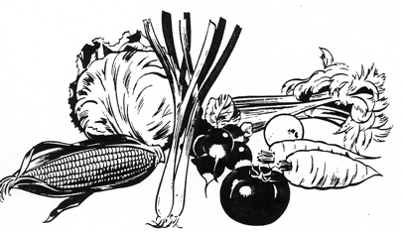**Vegetables - 112**

Class 112A - Corn

Class 112B - Beets

Class 112C - Greens

Class 112D - Beans

Class 112E - Carrots

Class 112F - Potatoes

Class 112G - Other

**Meats - 113**

Class 113A - Beef

Class 113B - Pork

Class 113C - Poultry

Class 113D - Mincemeat

Class 113E - Other

**n** tion **Division B – Food Preservation**

**Fruits and Tomatoes - 114**

Class 114A - Tomatoes, fancy pack

Class 114AA - Tomatoes, utilitarian pack

Class 114B- Pears

Class 114C- Apricots

Class 114D- Peaches

Class 114E- Bing Cherries

Class 114F- Plums

Class 114G- Apples

Class 114H- Fruit Pie Filling

Class 114 I - Other

**Division B – Food Preservation continued**

**Dried Products - 115**

Foods selected for drying should be fresh, firm, at peak of ripeness, and free from bruises. Pieces should be of uniform size and dryness, with no moisture showing when piece is broken. To be exhibited in medium weight, seal-top plastic bags (quart size). Must be labeled.

Class 115A - Dried Fruit (12) pieces

Class 115B - Fruit Leather (12) pieces

Class 115C - Dried Meat (12) piece

Class 115D - Dried Vegetables (1/2) cup

Class 115E - Dried Herbs (1/2) cup

Class 115F - Other

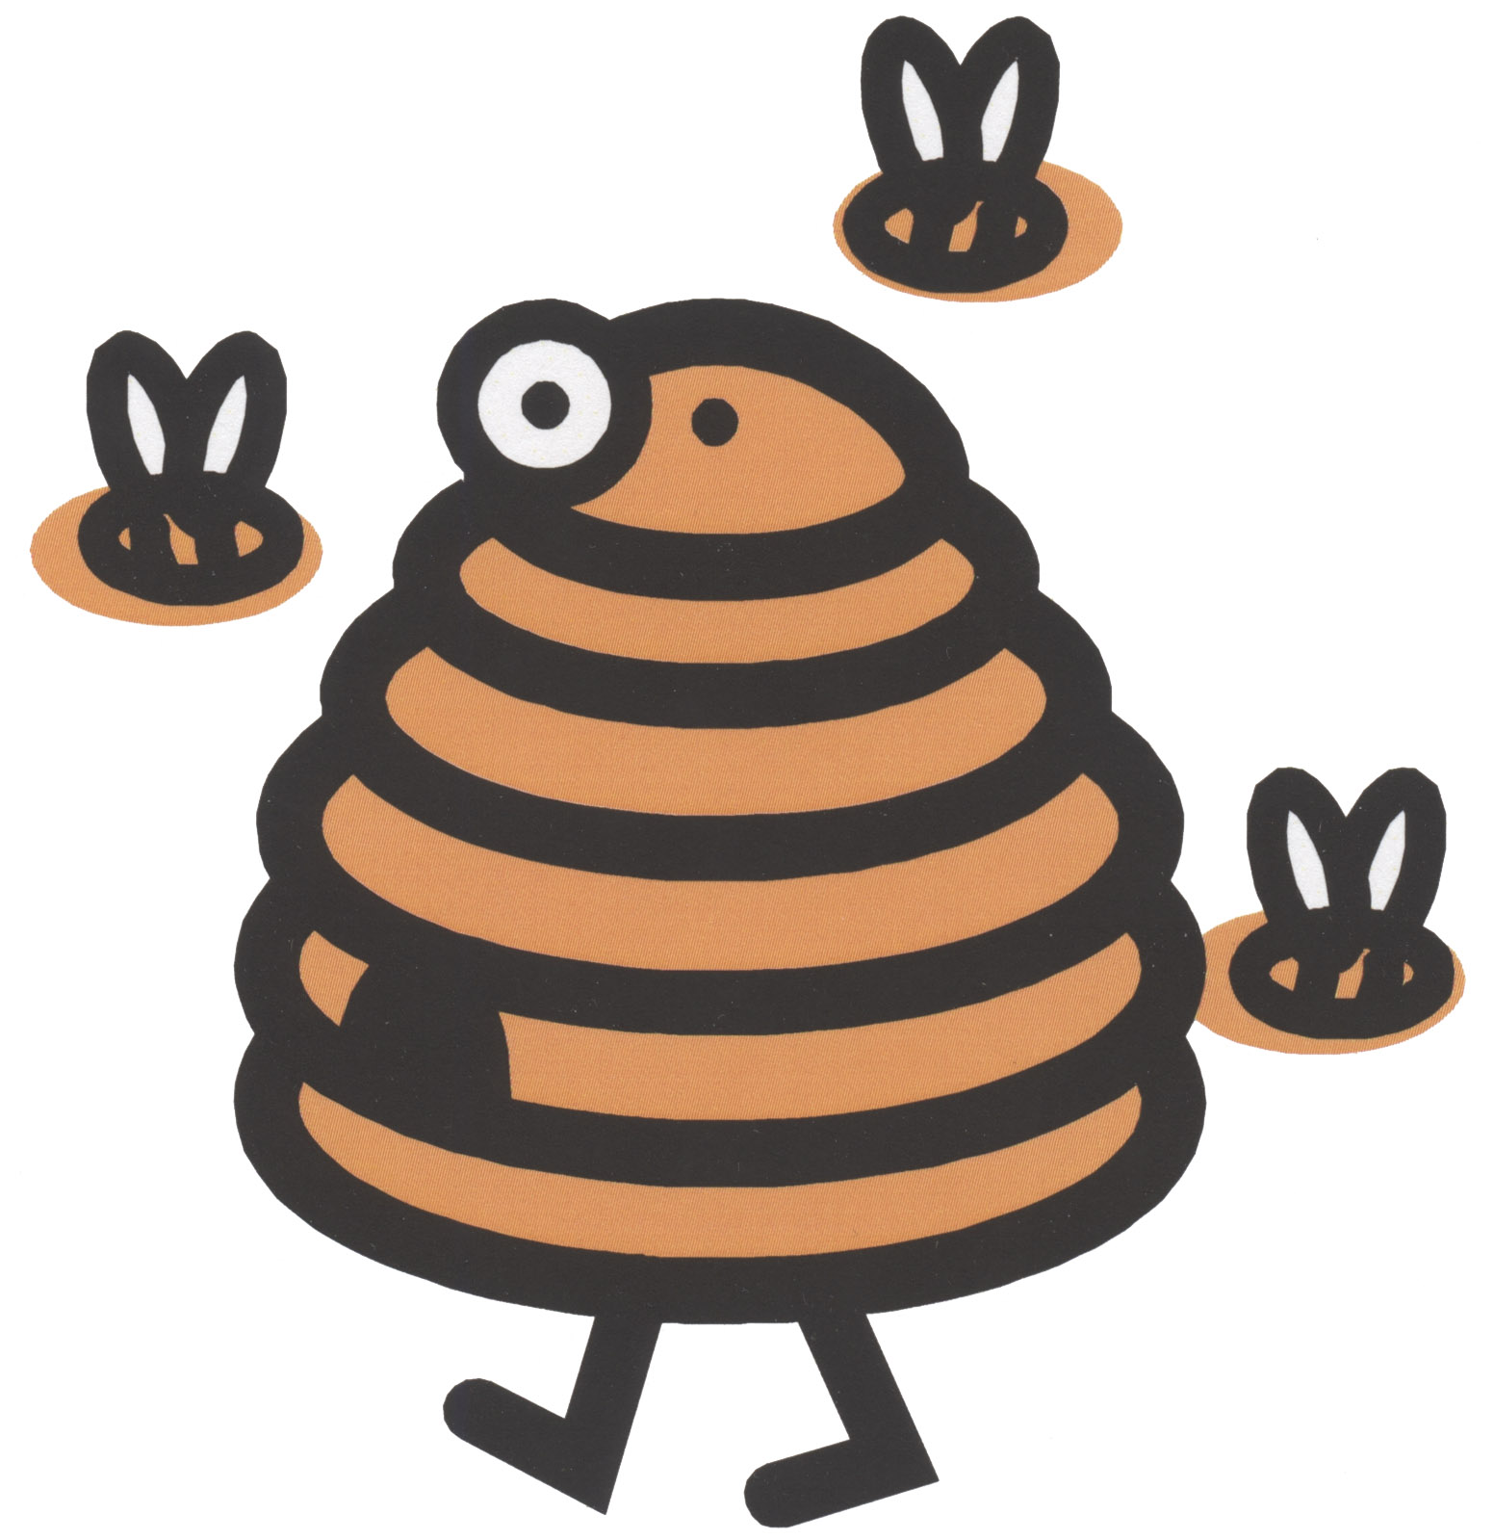

**Honey - 116**

Class 116A - Extracted Honey (light)

Class 116B - Extracted Honey (dark)

Class 116C - Chunk Honey

**Division C -- Wearing Apparel**

**Division Rules:**

A. Garments will be judged on construction, suitability of pattern, fabric, etc.

B. Garments may have been used before being exhibited, but if so, must be carefully laundered and pressed.

C. Children’s clothes made by senior division exhibitors may only be entered in Classes 117L-P.

### Wearing Apparel - 117

Class 117A - Men’s or Lady’s Jacket

Class 117B - Lady’s Suit; any fabric

Class 117C - Lady’s Coat

Class 117D - Lady’s Best Dress

Class 117E - Lady’s Casual Dress

Class 117F - Lady’s Sportswear

Class 117G - Men’s Sportswear

Class 117H - Three Piece Coordinated Suit: to be worn at one time

Class 117I - Lady’s blouse

Class 117J - Lady’s Skirt

Class 117K - Lady’s Vest

Class 117L - Child’s Coat or Jacket: Boys or Girls

Class 117M - Child’s Dress

Class 117N - Child’s Jumper

Class 117O - Child’s Smocked Garment

Class 117P - Child’s Sport Outfit or Play Clothes

Class 117Q - Miscellaneous construction (non-garments)

Class 117R - Doll clothes

Class 117S - Fabric collars

Class 117T - Aprons

Class 117U - Other than classified

**Decorate Your Duds - 118**

Decorative arts include embroidery, appliqué, macramé, painting, etc.

Class 118A - Garment constructed with use of decorative art - such as vest of macramé.

Class 118B - Garment to which decorative art design has been applied — garment may be purchased and the garment is not evaluated. Creativity is a major consideration in judging.

Class 118C - Recycled garment constructed with the use of decorative art.

Class 118D - Clothing accessory constructed or decorated with use of decorative art (hats, bags, scarves, belts, etc.)

Class 118E - Other garment — cannot be a duplicate of items exhibited in Classes 118A-D.

**Division D -- Needlework**

**Division Rules:**

A. Items should be neatly folded for display.

B. Other—means something NOT otherwise listed.

C. All pictures and wall hangings must be mounted and have a wire or secure hook for hanging or they will not be accepted.

**Rugs - 119**

Class 119A - Crocheted

Class 119B - Hooked

Class 119C - Other

**Quilts - 120**

Judged on a design or method of construction.

Class 120A - Crazy

Class 120B - Embroidered

Class 120C - Painted

Class 120D - Appliquéd

Class 120E - Patchwork/Piecework

Class 120F - Cross Stitch

Class 120G - Coat Quilts

Class 120H - Other

**Quilts - 121**

Judged on a quilting design and quilting stitches only.

Class 121A - Hand Quilted

Class 121B - Machine Quilted

Class 121C - Child’s Quilt

Class 121D - Lap Quilt

Class 121E - Other

**Quilted Article - 122**

Class 122A - Wall Hanging

Class 122B - Hoop

Class 122C - Wearing Apparel

Class 122D - Pillow

Class 122E - Runner (can be square)

Class 122F - Other

**Division D – Needlework continued**

**Afghans - 123**

Class 123A - Knitted, small

Class 123B - Knitted, large

Class 123C - Crocheted, small

Class 123D - Crocheted, large

Class 123E - Broomstick, small

Class 123F - Broomstick, large

Class 123G - Baby Afghan (any construction)

Class 123H- Other

**\*\* Small is defined as up to 36”**

**Crocheted Items - 124**

Class 124A - Doily

Class 124B - Table Cover

Class 124C - Sweater

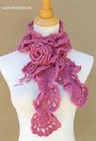Class 124D - Bedspread

Class 124E - Poncho or Cape

Class 124F - Scarf or Stole

Class 124G - Edging

Class 124H - Infant Set

Class 124I - Crocheted Bead

Class 124J - Purse

Class 124K - Collar

Class 124L - Slippers

Class 124M - Novelty

Class 124N - Bobbin Lace

Class 124O - Other

**Knitted Items - 125**

Class 125A - Sweater, without buttonholes

Class 125B - Sweater, with buttonholes

Class 125C - Stole or Scarf

Class 125D - Infant Set

Class 125E - Garment other than sweater

Class 125F - Other

**Tatted Items - 126**

Class 126A - Edging

Class 126B - Doily

Class 126C - Table Cover

Class 126D - Other

**Division D – Needlework continued**

**Tea Towel - 127**

Class 127A - Appliquéd

Class 127B - Painted

Class 127C - Embroidered

Class 127D - Other

**Pillow Case - 128**

Class 128A - Appliquéd

Class 128B - Painted

Class 128C - Embroidered

Class 128D - Drawn Work

Class 128E - Other

**Pillow – 129**

Class 129A - Knitted

Class 129B - Crocheted

Class 129C - Candle wicking

Class 129D - Pieced

Class 129E - Appliquéd

Class 129F - Counted Cross Stitch

Class 129G - Needlepoint

Class 129H - Crewel Embroidery

Class 129I - Latch hook

Class 129J - Stitch & Stuff

Class 129K - Novelty

Class 129L - Other

**Latch hook - 130**

Class 130A - Wall Hanging

Class 130B - Rug

Class 130C - Other

**Potholder - 131**

Class 131A - Crocheted

Class 131B - Knitted

Class 131C - Pieced

Class 131D - Appliquéd

Class 131E - Novelty

Class 131F - Hot Dish Mats

Class 131G - Other

**Division D – Needlework continued**

**Placemat - 132**

Class 132A - Crocheted

Class 132B - Pieced or Quilted

Class 132C - Embroidered

Class 132D - Woven

Class 132E - Appliquéd

Class 132F - Novelty

Class 132G - Other

**Needlepoint - 133**

Class 133A - Creative Design

Class 133B - Chair Seat

Class 133C - Wall Hanging

Class 133D - Bargello

Class 133E - Other

**Counted Cross Stitch - 134**

Class 134A - Pictures 5"x 7" & Under

Class 134B - Pictures larger than 5"x 7" but under 14"

Class 134C - Pictures 14" and larger

Class 134D - Sampler

Class 134E - Creative Design

Class 134F - Holiday

Class 134G - Other

**Stuffed Toys - 135**

Class 135A - Stuffed Doll

Class 135B - Stuffed Animal

Class 135C - Other

**Doll Clothes - Non-Constructed - 136**

Class 136A - Crocheted

Class 136B - Knitted

Class 136C - Other

**Division D – Needlework continued**

**Embroidery - 137**

Class 137A - Table Cover

Class 137B - Dresser Scarf

Class 137C - Liquid Embroidery

Class 137D - Candle wicking

Class 137E - Cut Art

Class 137F - Hardanger

Class 137G - Other

**Crewel Embroidery - 138**

Class 138A - Wall Hanging

Class 138B - Chair Seat

Class 138C - Creative Design

Class 138D - Other

**Stitch & Stuff - 139**

Class 139A - Wall Hanging

Class 139B - Other

**Weaving - 140**

Class 140A - Rug

Class 140B - Wall Hanging

Class 140C - Tablecloth

Class 140D - Afghan

Class 140E - Baby Blanket

Class 140F - Pillow

Class 140G - Shawl

Class 140H - Wearing Apparel

Class 140I - Other

**Miscellaneous - 141**

Class 141A - Rag Baskets

Class 141B - Novelty

Class 141C - Other

**Division E – Horticulture**

**Division Rules:**

A. Vegetables should be washed.

B. Entries must be on paper plates or aluminum-covered cardboard.

C. See extension pamphlet on “Exhibiting Fruits & Vegetables”.

D. All entries must be grown by the exhibitor this year.

**Vegetables - 142**

Class 142A - Collective Garden Exhibit—five different fresh vegetables. Only one variety of a specific vegetable may be exhibited. Any combination of small, medium, or large vegetables may be included in the entry. Quality and condition of the vegetables will be considered. The numbers of the five vegetables to be exhibited are as follows:

**Large Vegetables**—one each: watermelon, squash, pumpkin, eggplant, cabbage, and cantaloupe

**Medium Vegetables**—five each: cucumbers, tomatoes, carrots, beets, onions, peppers, parsnips, okra, Irish potatoes and sweet potatoes.

**Small fresh vegetables**- such as green beans are used as one of the five different vegetables; a dozen is suggested for a good display. Shelled vegetables should not be exhibited.

Class 142B - Tomatoes, standard garden variety (plate of 5), display bottoms up

Class 142BB - Tomatoes, Roma (plate of 5)

Class 142C - Tomatoes, cherry or grape (plate of 5)

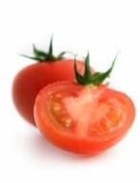Class 142CC- Tomatoes, Plum (plate of 5)

Class 142CCC Tomatoes, Heirloom (plate of 5)

Class 142D - Potatoes, red (plate of 5)

Class 142E - Potatoes, white (plate of 5)

Class 142F - Carrots (plate of 5)

Class 142G - Peppers, mango/bell (plate of 5)

Class 142H - Peppers, hot (plate of 5)

Class 142I - Cucumbers (plate of 5)

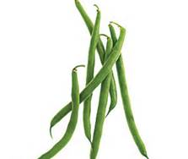Class 142J - Onions, white (plate of 5)

Class 142K - Onions, yellow (plate of 5)

Class 142L - Onions, red (plate of 5)

Class 142M - Beans, green snap (plate of 12)

Class 142N - Beans, yellow snap (plate of 12)

Class 142O - Squash, winter (one )

Class 142P - Squash, summer (1), other than zucchini

Class 142PP- Squash, zucchini (1)

Class 142Q - Pumpkin (one)

**Division E – Horticulture continued**

Class 142R - Cabbage (one)

Class 142S - Eggplant (one)

Class 142T - Beets (plate of 5)

Class 142U - Sweet corn with husks (plate of 5)

Class 142V - Okra (plate of 5)

Class 142W - Novelty Vegetable

Class 142X - Oddly grown

Class 142Y - Fresh Culinary Herbs, 6 stems of ONE VARIETY (not dried)

Class 142 Z- Other

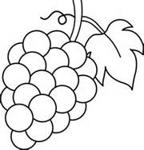**Fruits - 143**

Class 143A - Apples (plate of 5)

Class 143B - Peaches (plate of 5)

Class 143C - Pears (plate of 5)

Class 143D - Apricots (plate of 5)

Class 143E - Plums (plate of 5)

Class 143F - Grapes (3 bunches)

Class 143G - Watermelon (one)

Class 143H - Cantaloupe (one)

Class 143I - Other

**The Biggest Contest - 144**

True Value will provide prizes for the biggest contest.

Class 144A - Biggest Tomato

Class 144B - Biggest Potato

Class 144C - Biggest Pepper

Class 144D - Biggest Cucumber

Class 144E - Biggest Onion

Class 144F - Biggest Watermelon

Class 144G - Biggest Pumpkin

Class 144H - Biggest Cantaloupe

Class 144I - Biggest Squash

Class 144J - Biggest Cabbage

Class 144K - Biggest Eggplant

**Division F– Crops**

**Division Rules:**

A. All entries must be grown by the exhibitor this year.

B. Each entry must be labeled with the name and address of the exhibitor, class number and variety of crops.

C. The wheat exhibit shall be a one-gallon sample in a clear glass jar with a screw-on lid.

Class 145A - Red Winter Wheat

Class 145B - Grain Sorghum in heads (10 heads)

Class 145C - Alfalfa (10" flake)

Class 145D - Shucked Field Corn (10 ears)

Class 145E - 3" Diameter Wheat Sheaf

Class 145F - Tallest Sunflower Plant

Class 145G - Largest Sunflower Head

Class 145H - Tallest Corn Stalk (1 stalk)

Class 145I - Other



**Division G – Arts & Crafts**

**Division Rules:**

A. All entries must be original works of the exhibitor.

B. Framed pictures need to be ready to be displayed (hangers).

Class 146A - Metal

Class 146B - Plastic Canvas

Class 146C - Stone

Class 146D - Pastels

Class 146E - Acrylics

Class 146F - Oils—landscape

Class 146G - Oils—still life

Class 146H - Water colors

Class 146I - Colored Chalk

Class 146J- Crayon

Class 146K - Painting & chalking

Class 146L - Ceramics—dry brush finish

Class 146M - Ceramics—glazed/satin

Class 146N - Ceramics—stained finish

Class 146O - Paint by number

Class 146P - Wall Hanging, framed

Class 146Q - Wall Hanging, unframed

Class 146R - Burlap and rug wall hanging

Class 146S - Paper Maché item

Class 146T - Decoupage

Class 146U - Charcoal (mounted)

Class 146V - Pencil portrait (mounted)

Class 146W - Pencil landscape (mounted)

Class 146X - Pencil still life (mounted)

Class 146Y - Oil Portrait

Class 146Z - Candles

Class 146AA - Beads (strung)

Class 146BB - Macramé

Class 146CC - Macramé hanging W\pot

Class 146DD - Creative Idea

Class 146EE - String Art

Class 146FF - Tole Painting

Class 146GG - Novelty (new or unusual)

Class 146HH - Stained glass

Class 146II - China Painting

Class 146JJ - Models

Class 146KK - 1 bar homemade soap

Class 146LL - Colored Pencil

Class 146MM - Jewelry

**Division G – Arts & Crafts continued**

Class 146NN - Pen & Ink

Class 146OO - Leather Craft

Class 146PP - Scrap Booking (3 representative pages - no entire books)

Class 146QQ - Gourds, Decorated

Class 146RR - 3-dimensional paper entries

Class 146SS - Flat paper entries

Class 146TT - Mixed Media (at least 2 different media used)

Class 146UU - Button entries

Class 146VV**- Barn Quilt paintings (maximum size 2'x2')

Class 146WW - Coloring book entries (1 page)

Class 146XX - Stick Art (popsicle sticks, matches, pencils, etc)

Class 146YY - Other

**Qualifying Barn Quilt paintings may be entered into the County Fair Contest for Barn Quilts at the Kansas State Fair. If you wish to do that, see the Kansas State Fair Handbook for additional rules and requirements or check with the Extension Office.

**Division H - Woodworking**

**Division Rules:**

A. Each exhibitor is limited to one article in each Class.

B. Articles are to be made by exhibitor.

C. Exhibit area for each article is limited to ten square feet of floor space.

Class 147A - Picture frame

Class 147B - Woodworking articles for home

Class 147C - Woodworking articles for farm or shop use

Class 147D - Lawn Furniture

Class 147E - Household Furniture

Class 147F - Games or Toys

Class 147G - Repaired or Refinished Furniture (include a before picture and explanation of refinishing)

Class 147H - Caning

Class 147I - Re-upholstered (include a before picture and explanation of refinishing)

Class 147J - Children’s furniture

Class 147K - Carving - people

Class 147L - Carving - animals

Class 147M - Carving - relief

Class 147 N - Carving - Walking Stick/cane

Class 147 O - Carving - Human Face

Class 147 P - Carving - Caricature

Class 147 Q - Carving - Beginner (first time entry)

Class 147 R - Chip - Carving

Class 147 S - Carving - Unusual Wood Piece

Class 147 T - Other

**Division I - Floriculture**

**Division Rules:**

A. Fresh flowers are to be used in all arrangements.

B. Name the variety or species.

C. Exhibitor will furnish all equipment and containers necessary to display their exhibit.

D. More than 1 entry is allowed in classes 148I & 152H but only 1 entry per holiday.

Class 148A - Garden flowers for buffet luncheon centerpiece - 12" height

Class 148B - Garden flowers for sit-down luncheon centerpiece - 9" height

Class 148C - Roses arranged for dinner centerpiece (other foliage permitted) -

9" height

Class 148D - Novelty arrangement for man’s sick room

Class 148E - All white using white flowers and white or clear glass

Class 148F - Miniature arrangement—5 inches or less

Class 148G - Centerpiece using vegetables, flowers, or combination of these

Class 148H - Kitchen arrangement

Class 148I - Holiday arrangement

Class 148K - Live Wildflower arrangement

**Potted Plants - 149**

Class 149A - Hanging Planter

Class 149B - Small house plant—12" or less (height/cascade or across)

Class 149C - Large house plant—more than 12" (height/cascade or across)

Class 149D - Cactus

Class 149E - Succulent

Class 149F - Other

**Specimens - 150 - (Suitable Containers)**

It is suggested to have foliage with the specimen. Submit a single stalk/stem.

Class 150A - Aster

Class 150B - Balsam

Class 150C - Bells of Ireland

Class 150D - Cannas

Class 150E - Cockscomb, Plumed

Class 150F - Cockscomb, Crested

Class 150G - Cosmos

Class 150H - Dahlia, Large (5" dia.)

Class 150I - Dahlia, Small

Class 150J - Daisy, Gloriosa

Class 150K - Daisy, Shasta

Class 150L - Daisy, Other

Class 150M - Dianthus

Class 150N - Everlasting, Fresh

**Division I – Floriculture**

Class 150O - Gaillardia

Class 150P - Gladiolus

Class 150Q - Lily, Type, Name

Class 150R - Marigolds, African/American

Class 150S - Marigolds, French

Class 150T - Petunia, single

Class 150U - Petunia, double

Class 150V - Phlox, Annual

Class 150W - Phlox, Perennial

Class 150X - Rose, Hybrid Tea, and Name variety

Class 150Y - Rose, Grandiflora, Name variety

Class 150Z - Rose, other than above

Class 150AA - Rudbeckia

Class 150BB - Salvia

Class 150CC - Snapdragons

Class 150DD - Sunflowers

Class 150EE - Verbena

Class 150FF - Vinca, Periwinkle

Class 150GG - Wildflower

Class 150HH- Zinnia, Dwarf

Class 150II - Zinnia, Medium

Class 150JJ - Zinnia, Giant

Class 150KK - Hibiscus

Class 150LL - Other Annual

Class 150MM - Other Perennial

**Specimens - 151 (collection of five different kinds)**

Class 151A - Annuals

Class 151B - Perennials

Class 151C - Wild flowers - named

Class 151D - Other

**Dried Flowers - 152**

Class 152A - Fall bouquet using grasses, wheat, or dried, local plant materials in their natural colors in a suitable container

Class 152B - Arrangement of dried wild flowers

Class 152D - Arrangement of artificial flowers

Class 152E - Flowered Swag (dried or artificial)

Class 152F - Wreath of dried or artificial flowers

Class 152G - Flower arrangement made from nature

Class 152H - Holiday arrangement

Class 152I - Other

**Division J - Photography**

**Division Rules:**

A. Photographs must be at least 4 x 6 inches BUT NO LARGER THAN 8 x 10 inches. They must be mounted or matted so they don't curl when hung. Maximum size of the mat or mounting board for individual photos is 11 x 12.5". Mats for the group of five 4" x 6" photos may exceed the above maximum size.

B. Framed photographs are not accepted.

C. Still life—a picture consisting predominantly of a single or small set of inanimate objects.

D. Group series photos must be matted together on a single mat.

E. The same photo may not be entered in more than one class even if it has been processed differently. (i.e. one in color one in black and white.)

**F. The exhibitor’s name must be written on the back of the mount.**

G. By entering, all exhibitors agree that, if their photo is selected as the overall Photography Sweepstakes winner, the winning entry will be retained for display in the J.H. Robbins Library. The winning entry may be returned to the winner if the winner provides the sponsor with an 8 x 10 copy by September 1.

H. Multi-page photo books cannot be accepted.

I. Solid-color sepia photos will be considered to be black and white.

**Photography - 153**

Class 153A - Scene, black and white photograph

Class 153B - Animal, black and white photograph

Class 153C - People, black and white photograph

Class 153D - Group of 5 related series of pictures, black and white (4 x 6)

Class 153E - Scene, color photograph

Class 153F - Animal, color photograph

Class 153G - Insects, color photograph

Class 153H - People, color photograph

Class 153I - Group of 5 related series of pictures, color (4x6)

Class 153K - Still Life, color or black/white

Class 153L - Flowers, color

Class 153M - Snow Scene, color or black/white

Class 153N - Country Scene, color or black/white

Class 153O - City Scene, color or black/white

Class 153P - Sports picture, black/white

Class 153Q - Sports picture, color

Class 153R - Picture, special effects

Class 153S - Other

**Photography Sweepstakes Award**

**1. The winner shall be selected from Junior and Senior Blue Ribbon entries only.**  All classes are eligible for consideration.

2. The winning photograph may be any size; however, the overall champion shall provide the sponsor with an 8 x 10-inch enlargement for his possession by November 1. The winner’s name will be placed on a plaque that shall be displayed at the Library along with the 8 x 10-inch photograph.

3. The winner must sign a release stating he will provide sponsor with an

8 x 10-inch enlargement and will allow the sponsor to use the photograph in any capacity deemed appropriate.

4. The individual with the winning entry shall receive a special prize if the above conditions are met.

***Release Statement***

NAME__________________________________________________________

TITLE__________________________________________________________

CLASS NUMBER________________________________________________

DATE__________________________________________________________

If my entry is selected for the Photography Sweepstakes Award, I will provide Ellsworth County Fair Association with an 8 x 10-inch enlargement and I will allow the sponsor to use the photograph in any capacity deemed appropriate.

SIGNATURE____________________________________________________

**Division K – Tag-Along Livestock**

**Division Rules:**

A. Exhibitors ages 5 & 6 as of January 1 of the current year are allowed to participate.

B. Exhibitors may use an animal in his/her possession or may use another animal that is to be exhibited in the 4-H Division of the same class, i.e. bucket calf, swine, sheep, goats, and horse.

C. One entry per specie allowed.

D. Classes are showmanship only.

E. Classes are non-competitive.

F. **Participants must pre-enter in this division**. Pre-entry forms are available at the Extension Office and must be returned no later than July 1.

G. Exhibitors in this division planning to show an animal pre-entered in the 4-H Division **must obtain written permission from the owner to be eligible for pre-entry.**

H. **All animals that will be exhibited in this division (whether in possession of or exhibiting a pre-entered 4-H exhibit of the same class) must be identified and pre-entered in the Tag-Along livestock division. No late entries will be allowed to show.**

I. Any animal deemed “wild” will not be allowed to show.

J. Stall space at the barn will be assigned by the Tag-Along Livestock committee.

K. All sick animals will be barred from the Fair. No health requirements other than those listed under each species, except in the event of a sudden disease outbreak in the county.

L. Animals must be in stalls or pens between 9:00 a.m. and 9:00 p.m., except when showing, washing, or feeding.

**Bucket Calf – 154**

*Special Rules:*

1. Calves must be born between January 1 and May 1 of the current year.
2. Calves must have been weaned prior to July 15 of the current year.
3. Each calf must be broke to lead.
4. Calves must stay at the Fair until all exhibits are released.
5. Calves should be properly groomed.

Class 154A - Bucket Calf

**Tag-Along Livestock continued**

**Goat – 155**

*Special Rules:*

1. Artificial coloring, paint, adhesive, or powder will not be permitted for use on goats during the entire show.
2. Communicable Disease/Club Lamb Fungus – All goats will be visually inspected by a veterinarian for sore mouth, infectious skin lesions (ringworm) and general health. This will be done as you check in your goat. All blankets must be completely removed from all goats at check-in. Any goat found to be infected with active fungal lesions, or other health problems, must be removed from the premises. Any goat may be required to undergo a second health inspection at the Superintendent’s request.
3. Bracing: Goats cannot be braced and must be shown with all four feet on the ground. Animals must be shown with a chain or collar used only to control the animal. Exhibitors may use collars, collars with a short lead or halters when showing. No extreme collars (spike/training) will be allowed. Exhibitors can only briefly touch their animal with their body and cannot use the chain/collar to make their animal tense their muscles.
4. Teeth: All wethers must have baby teeth in place with no visible signs of permanent teeth. The decision of the mouther is final.
5. Shearing: All wethers must be “slick shorn” with an equal amount of hair above the knee and hock before arrival on the grounds. A maximum of 0.4 (four tenths) inch of hair is permitted. Hair on the tail switch is permitted.
6. Horns: Wethers are suggested to be dehorned. However, if horns are left, they should be tipped and rounded.

Class 155A - Goat

**Swine – 156**

*Special Rules:*

1. All swine must be free of parasites.
2. Sick hogs will be barred from the show.

Class 156A - Hog

**Tag-Along Livestock continued**

**Horse – 157**

*Special Rules:*

1. Horses will be brought in only for the day of judging, with the 4-H horse show.
2. The horse’s name must be listed on the pre-entry form.

Class 157A - Walk-Trot Showmanship

Class 157B - Walk-Trot Horsemanship

**Sheep – 158**

*Special Rules:*

1. No artificial coloring will be allowed on the lamb except on the hooves.
2. Market lambs must have been slick shorn prior to check-in with equal length of wool over the entire body.
3. Animals must be checked for club-lamb fungus at check-in, before being allowed in the barn.
4. Any intact male or female sheep must have scrapies tag present before they may be exhibited at the Fair.

Class 158A - Sheep

**Division L -- Ag/Industrial Technology**

1. Projects dealing with shop & farm mechanics or technology may be entered.

2. Project Considerations:

A. Creativity - novelty & originality

B. Significance - cultural importance of the design

C. Complexity - significance & technical sophistication

D. Feasibility - degree of being easily or conveniently done

3. Projects shall be judged on the basis of:

A. Construction & workmanship

B. Materials & finish

C. Practical value and use (functionality)

**Division Rules:**

1. Projects should be geared toward student mechanics projects.

2. Items cannot exceed 20 foot in length (IE, large trailer).

3. Contest space is limited. When display area is full, no more entries will be accepted.

**Class 160 - Mechanics**

*Special Rules*

*All items must be rebuilt or refurbished by the entering individual.*

*No company auto body or welding work done by corporation will be accepted.*

**Class 160A - Metal fabrication**

Welding, wrought iron, metal machining, sheet metal, metal casting, forging, etc.

**Class 160B - Small engines**

*Special Rules:*

2 or 4 cylinder engines are acceptable.

Items cannot exceed the size of a 4-wheeler (NO car, truck, or larger engines)

**Class 160C - Electrical**

*Special Rules:*

Items may not exceed a 3-foot by 3-foot display area.

**Small Shop Projects - 161**

*Special Rules:*

Items cannot exceed $250 in building costs

**Class 161A - Small Shop projects**

.

**Ag/Industrial Technology continued**

**Large Shop Projects - 162**

*Special Rules:*

Includes items $251 and above in building costs. Example: a trailer

Items cannot exceed 20 feet in length.

**Class 162A - Large Shop projects**

**Sample Entry Form**

**PICK UP YOUR ENTRY NUMBER WHEN YOU REGISTER**

Exhibitor Number _________ Age _____ Age _____ Exhibitor Number _______

(Only if Junior) (Only if Junior)

Name ______________________________ Name ________________________________________________

Division ____________Class No__________ Division_________________________ Class No.______________

Class Name __________________________ Class Name ____________________________________________

Ribbon Sticker here

Blue White Blue White

Purple Red Participated Purple Red Participated

**A sample open class entry tag is shown above. To help in your registration, please complete both halves of the entry tag according to the division you are entering in the Open Class Fair. It is important to write out the class name.**

**Senior Division entry tags are LEMON.**

**Junior Division entry tags are GREEN.**

**Professional Division tags are LEMON WITH COLORED BAR across the top.**

**\*\*\*THIS IS A SAMPLE\*\*\***

**The Division, Class No., and Class Name will be according to each individual entry.**

**Livestock Judging Contest**

Open to ALL ages.

1. Arrive at fairground and sign in 15 minutes before the contest begins.
2. Contestants will judge four classes of livestock. May include: market steers, breeding heifers, market lambs, breeding ewes, market hogs, breeding gilts, market goats or breeding meat goats. Data may be included on a breeding class.
3. Age divisions as of January 1:
   1. Senior 14-19 years old (1 set of oral reasons and 1 set of questions)
   2. Intermediate 10-13 years old (1 set of oral reasons)
   3. Junior 9 years and under (1 set of questions)
   4. Adults 20 years and over (placings only)

**Youth Agriculture Scavenger Hunt**

The Youth Agriculture Scavenger Hunt is an event at the fair and is open to ALL youth.

The scavenger hunt provides youth an opportunity to learn about agriculture as they enjoy the sights and sounds of the exhibits.

Youth can pick up an activity sheet at the Farm Bureau table at the Parade of Champions on Thursday evening. The activity sheet contains agricultural questions. The youth can 'hunt' for posters around the fair exhibits. These posters contain the information necessary to complete the activity sheet.

The completed activity sheet should be returned to the Farm Bureau table for a prize.

The goal of the project is to help youth gain a better understanding of agriculture and its importance to Kansas.

For more information, contact:

Sarah Goss, County Coordinator

Ellsworth County Farm Bureau Association

785-531-2966 or 785-472-3082

[ellsworthfb@kfb.org](mailto:ellsworthfb@kfb.org)

Sponsored by:



**Local Conservation Photo Contest  
 in conjunction with the Ellsworth County Fair   
OPEN CLASS YOUTH Photography Class.**

# The Ellsworth County Conservation District will sponsor the *Best Conservation Photo; Junior Division (Open Class)* and provide a $50.00 cash prize for the award at the Ellsworth County Fair. The winning photo will also be entered into Kansas Association of Conservation District (KACD) State Contest with possibility for additional cash prize at KACD Contest.

To participate in the Ellsworth County Conservation Districts Conservation Photo Contest entries must follow all rules as printed in the Ellsworth County Fair book that pertain to youth open class photography.

Subject matter must be CONSERVATION PRACTICES (cover crops, waterways, terraces, pollinators, pest management, wildlife habitat, water quality & soil health) within Ellsworth County.

The winning photograph must be surrendered to the Ellsworth County Conservation District immediately after the fair for submission to the KACD contest. The photographer and a parent will be required to sign a release form for KACD.

* Photos must have been taken between August 1 of the previous year and July 1 of current year.
* Minor digital enhancements for cropping, red eye removal, filters and corrective functions are permitted; but images that have been altered in any significant manner will be disqualified.
* Previously published photos may not be entered.
* Upon surrendering winning photo to the Ellsworth County Conservation District, the photographer must also provide a typed brief description of photo; date and location photo was taken; entrants name, age, address; and the words ELLSWORTH COUNTY and slide this paper into the plastic sleeve with the photo. PHOTO RELEASE FORM (below) must be completed and placed in the plastic sleeve with each photo as well.
* 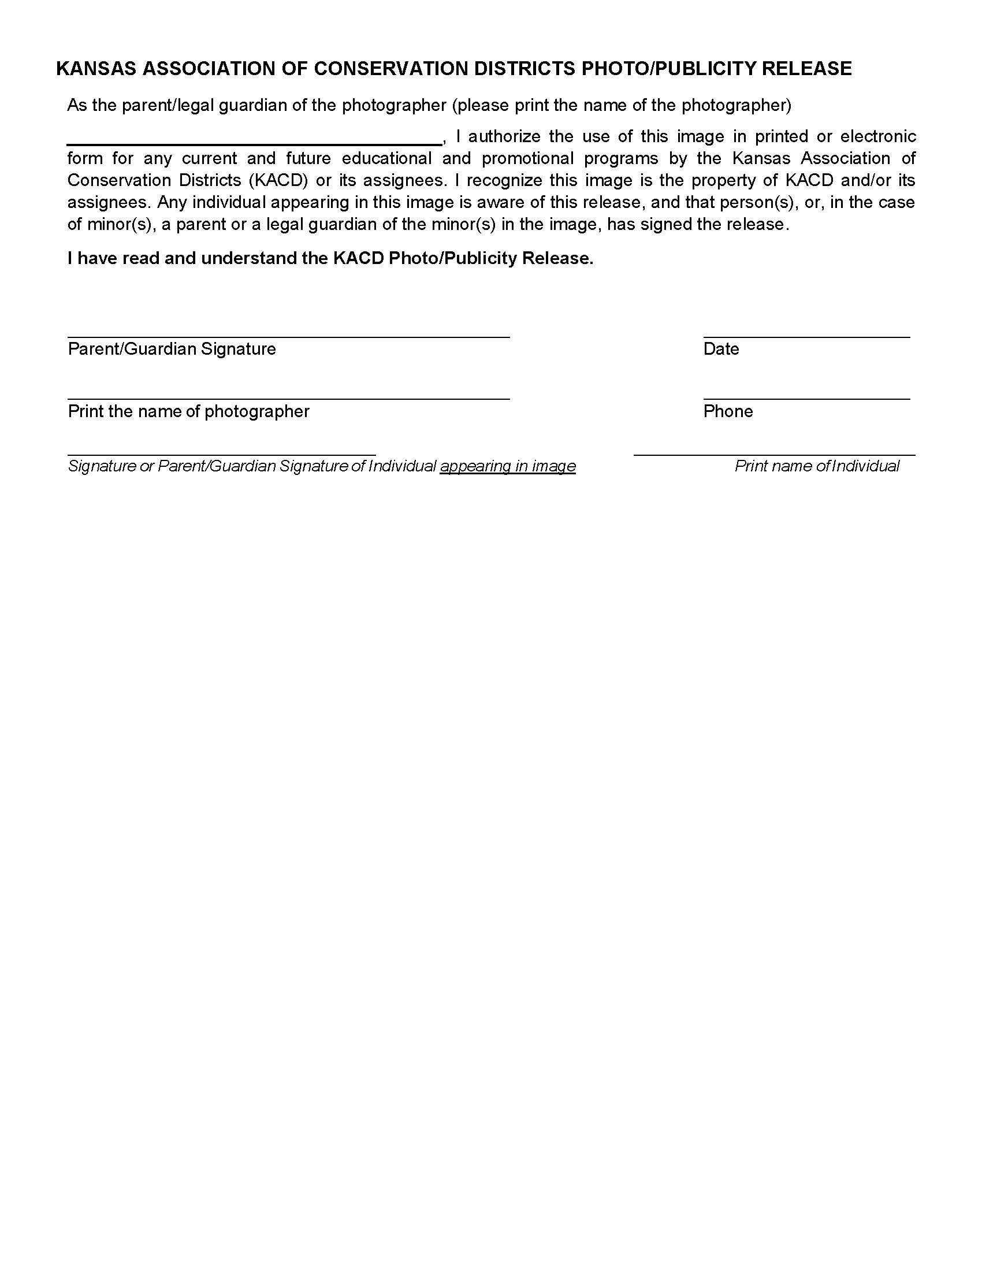The Conservation District Office is located in the USDA Service Center at 402 W 15th St, Ellsworth.

(Forms available at the Conservation District Office   
and the Extension Office.)