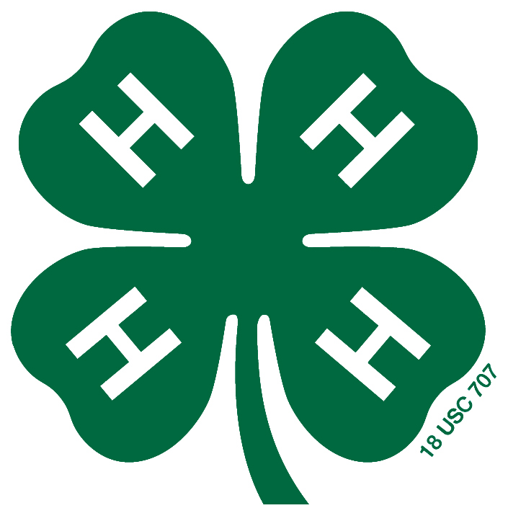
2020 Style Revue

Sunday, July 12, Judging 12:00 noon – Public Revue 3:30p.m.
Dress Le You
Are Already
FAMOUS!!!
Lucas Community Theater
Entries Due: July 1 5p.m.

4-H Style Revue Description Sheet
4-H’ER MUST COMPLETE:
Garment Type____________________
Color___________________________
Shoes___________________________
Accessories______________________

- For narration use
- Type or print neatly
- Use one sheet per outfit
- No changes or additions after due date
- MUST provide a picture in outfit to be
turned in with entry sheets

Optional: Place fabric sample here
Circle one: Constructed or Purchased or Thrift Store
Class # ____________ Age ________
Name __________________________
Club ___________________________

Description should include: Name, whether outfit is purchased or constructed, fabric content and color, accessories worn and where outfit is to be worn. Try to incorporate the Theme in your description.

Example: Sara Lee is ready to head to the carnival in her relaxed fitted 100% cotton denim jeans. They have a low rise fit, 19" leg openings and antique metal hardware for a comfortable, worn-in look. Her pink polo shirt is designed with reinforced woven taping through the collar, placket and side vents for added strength, and petite buttons. It is made from stretchy textured pique cotton. To complete her outfit, Sara is wearing pink flip flops.

100 Word Limit

