2023
Ellsworth County
Open Class Fair

July 17- July 20, 2023

Exhibits: Ellsworth Armory

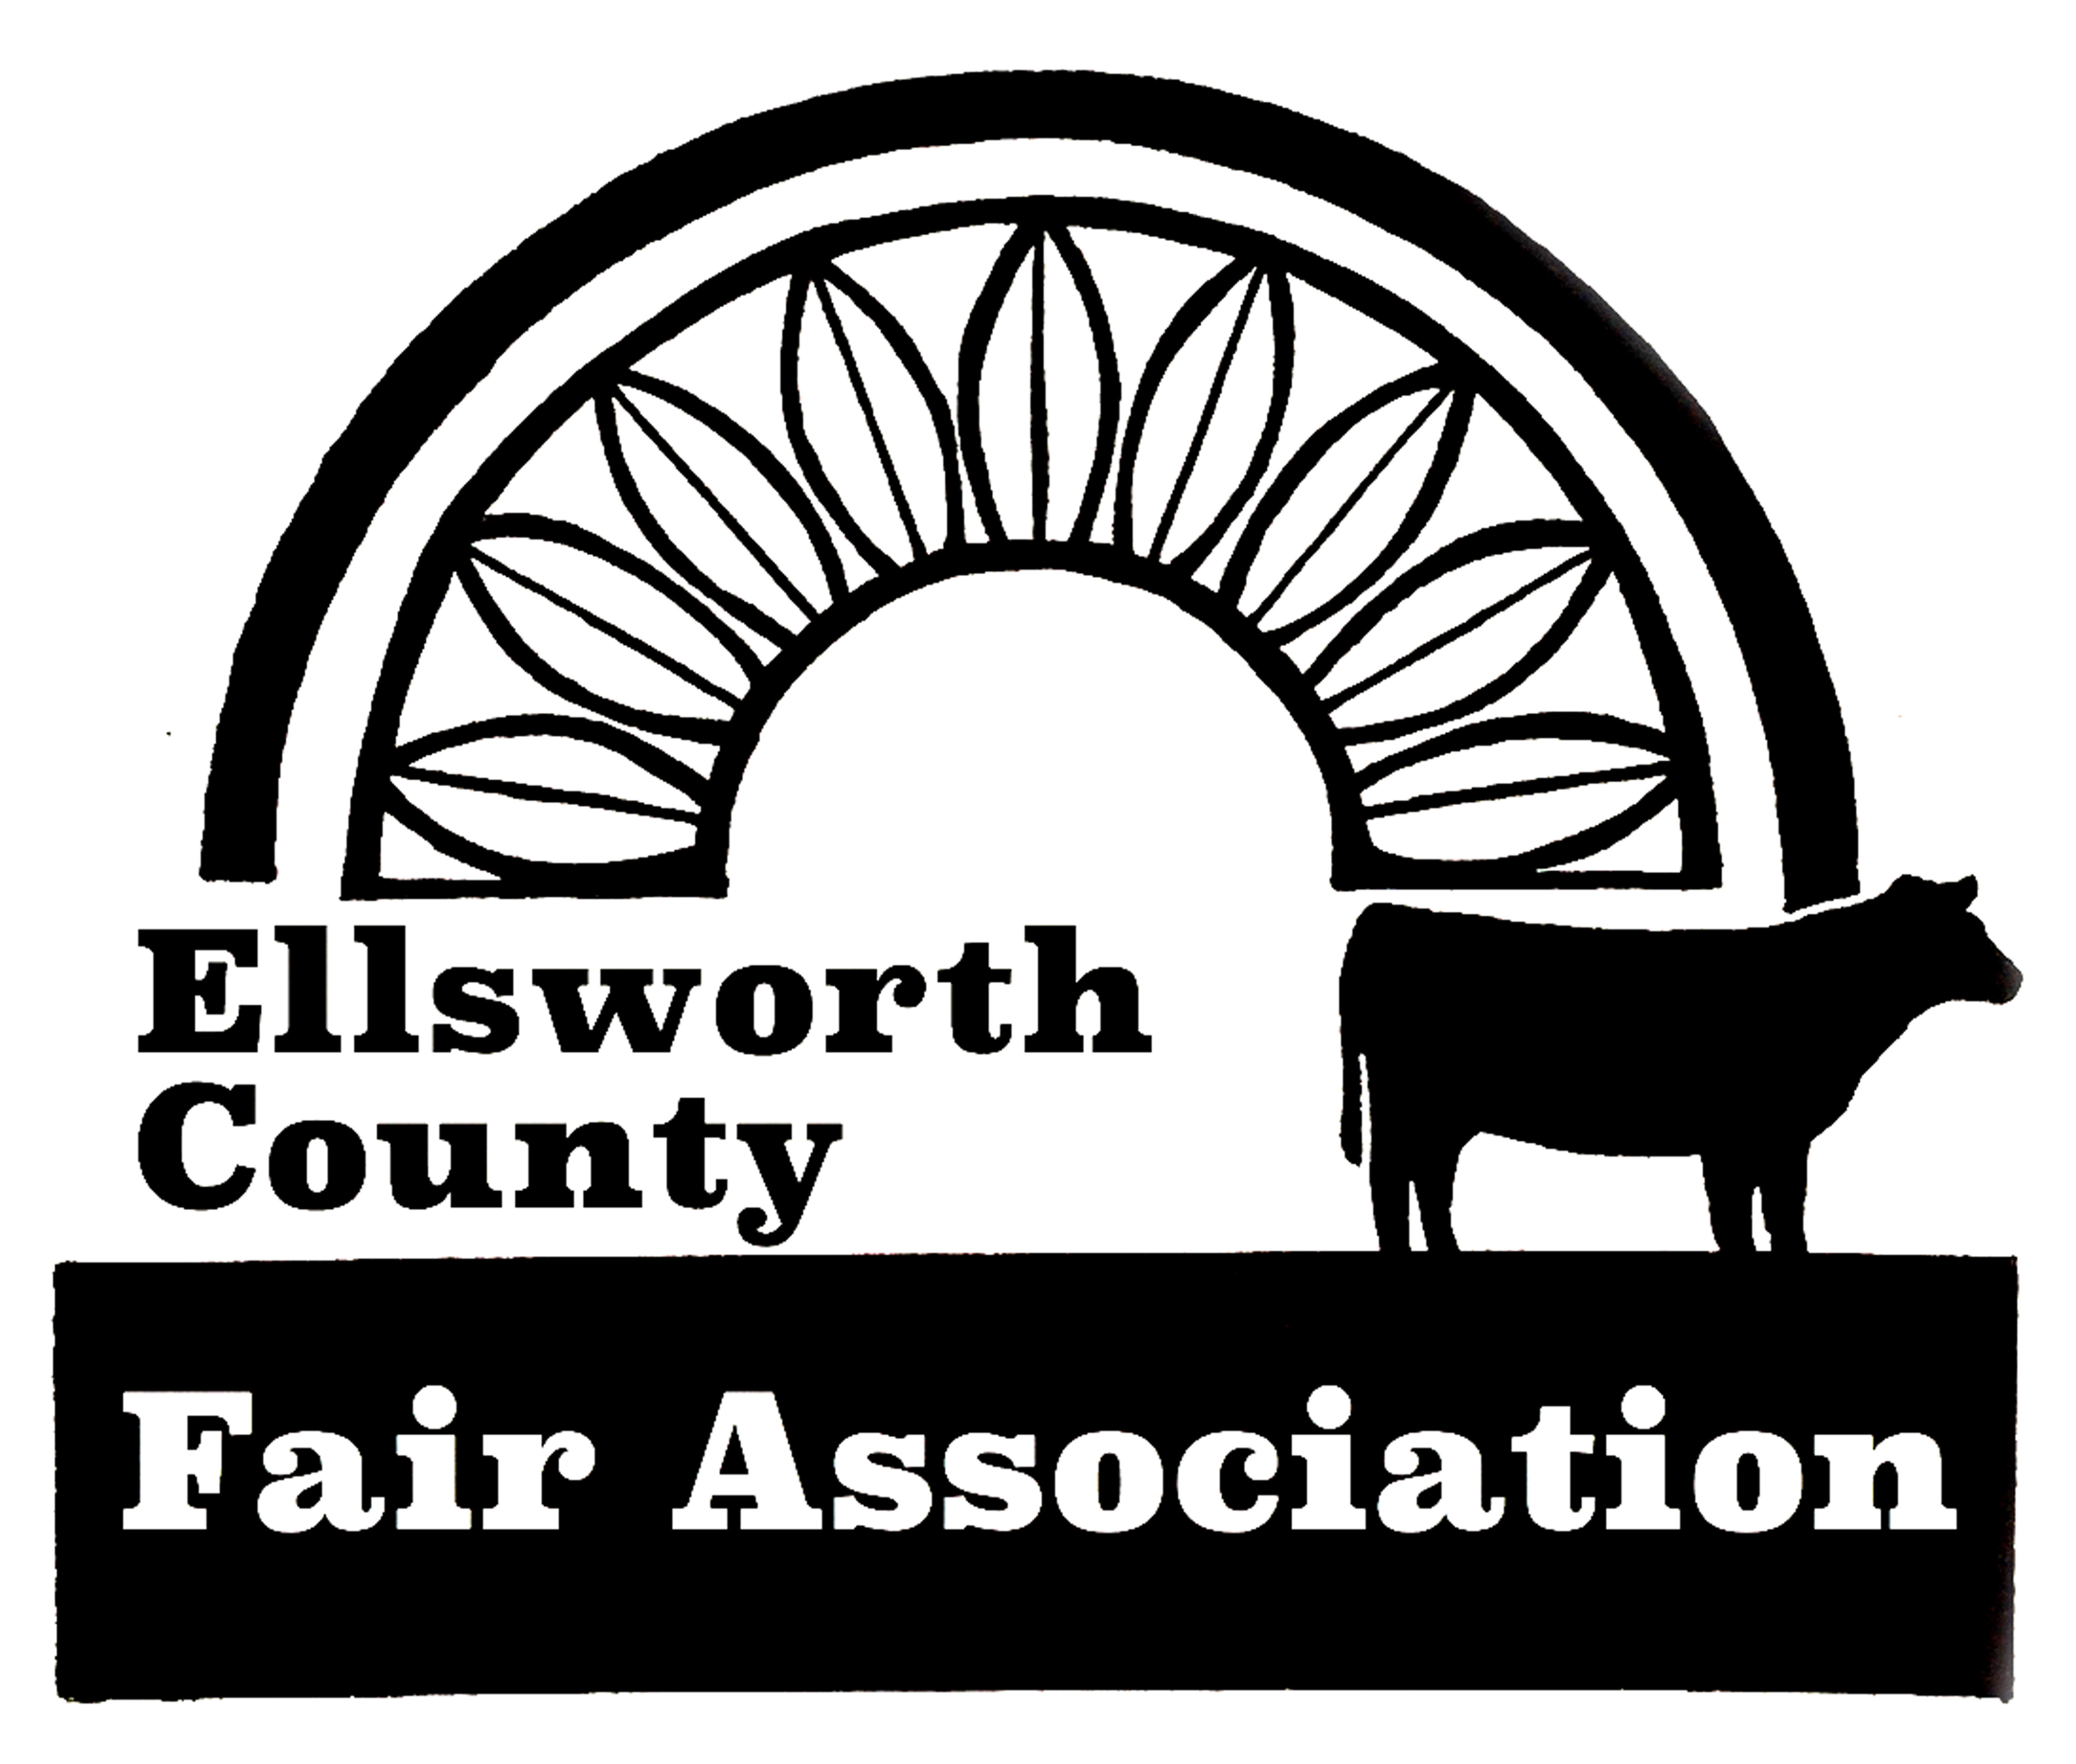

Table of Contents

Page No.
Fair Superintendents 2
Special Prizes 3
Schedule of Events 4
Open Class Fair General Rules 4-5

Divisions (Check each division for specific rules.)
A - Foods 6-7
B - Food Preservation 8-9
C - Wearing Apparel 9
D – Needlework …………………………………………………………. 10-11
E – Horticulture ……………………………………………………….. 12-13
F - Crops 14
G - Arts & Crafts ………………………………………………………... 15
H - Woodworking 16
I – Floriculture ………………………………………………………….. 16-17
J – Photography ………………………………………………………….18-19
K - Tag-Along Livestock ……………………………………………….. 20-22
L - Agricultural/Industrial Technology ………………………………. 23
Sample Entry Tag 24
Livestock Judging Contest ……………………………………………….. 25

Research & Extension is an equal opportunity provider & employer.
Open Class Fair Superintendents

Help is needed for ALL Divisions of the Open Class Fair. To volunteer, contact the Ellsworth County Extension Office at 785-472-4442.

Foods
Food Preservation
Wearing Apparel
Needlework
Horticulture
Crops
Arts & Crafts
Woodworking
Floriculture
Photography
Ag/Industrial Technology

Tag-Along Livestock
Delane Janssen
Clayton Huseman
Sharla Huseman
Katie Kueser
Sarah Goss

Ag/Industrial Technology Karl Dawn Stover

Livestock Judging Karl Dawn Stover

Open Class Special Prizes

Best of Show and special prizes

We are going to try and improve our 2023 Open Class Fair Experience. The
entry system should be easier and hopefully offer bigger awards for winning
your category. First, second, and third place prizes will be awarded in each
division.

For 2023 we will have a Junior/Senior Division in the following categories:

Division A: Foods Exhibit
Division B: Food Preservation
Division C: Clothing Exhibit
Division D: Needlework-Quilt
Division E: Horticulture Exhibit
Division F: Crops Exhibit
*Biggest Contest
Division G: Arts & Crafts Exhibit
Division H: Woodworking Exhibit
Division I: Floriculture Exhibit
Division J: Photography Exhibit
Division K: Tag-Along Livestock Participation
Division L: Ag Industrial Technology Exhibit

Schedule of Events

MONDAY, July 17
1:00 p.m. …………Set Up Open Class Fair: All Committees assist
7:00 - 9:00 p.m. ……………………..Check In Open Class Exhibits

TUESDAY, July 18
8:00 - 9:30 a.m. ……………………..Check In Open Class Exhibits
10:00 a.m………………………………………Open Class Judging
1:00 p.m. ……………………...Open Class Ag Mechanics Judging

Wednesday, July 19
8:00 a.m. - 9:00 p.m……………………….Exhibits Open to Public
Rabbit and Poultry Tag Along after Swine Show on Wednesday

Thursday, JULY 20
8:00 a.m. - 7:00 p.m………………………Exhibits Open to Public
9:00 a.m. ……………………………Open Class Tag Along Show:
Bucket calf, goat, sheep and swine
1:00 p.m………………………………...Livestock Judging Contest
7:00 – 9:00 p.m…………Open class check out and exhibit pick up
8:00 p.m. ………………………Clean Up: All Committees assist

Open Class Fair Rules

1. Same class numbers will be used for Junior, Senior and Professional categories. Exhibits of Fair Divisions will be judged in the following three categories and entry card must show age of Junior exhibitor:

Junior - green entry card - 5-14 years of age, January 1 of current year.

Senior - lemon entry card - 15 and over by January 1 of current year.

Open Class Fair Rules continued…

2. Exhibits made in school or other organizations will be allowed to enter.
3. Rules must be followed, or entry will be disqualified.
4. All exhibitors must check in by getting an exhibitor’s number at the entry table.
5. Exhibitors won’t be limited to entries per category for 2023.
Like items can only be shown in one category.
6. Any article that was previously judged or exhibited at any Ellsworth County Open Class Fair or 4-H Fair may not be exhibited again.
7. The exhibit must be the work of the exhibitor.
8. All entries shall be entered during the check in times outlined in the schedule. NO EXCEPTIONS!!!
9. All entries will be on display in the Ellsworth Armory.
10. All entries are to be released Thursday evening, between 7:00 – 9:00 p.m. Please pick up prize money when checking out exhibit. Exhibitors removing entries before this time must forfeit awards.
11. 1st place, 2nd place and 3rd place will be award on each division for both the junior and senior division. The biggest vegetable contest no ribbons will be given, but prizes awarded.
12. Award money for 1st place, 2nd place and 3rd place ribbons should be collected when exhibit is picked up. All other special prizes will be awarded at checkout time only. No early releases.
13. ALL POSSIBLE CARE WILL BE TAKEN OF THE EXHIBITS, BUT THE COMMITTEE IN CHARGE WILL IN NO CASE BE RESPONSIBLE FOR ANY LOSS OR DAMAGES SUSTAINED.
14. Other - means something NOT listed in any other class.
15. “The Biggest Contest” has no age divisions and only one prize per family.
16. Items on display cannot be sold or advertised.
17. Department Supervisor reserves the right to change the class an exhibit is entered in.
Division A – Foods
Division Rules:
A. Place foods on carefully wrapped, flat surface CARDBOARD covered with aluminum foil or on firm, disposable plates for small items.
B. All foods must be in a clear, fly proof plastic bag. Securely seal bag.
C. Commercial mixes are not to be used except in Class 103D.
D. The entire exhibit will be put on display after it is judged.
E. All cakes must be baked in an 8" or 9" round or square pan unless otherwise specified (no 9x13" pans).
F. Age of Jr. Division exhibitor must be on the entry card.
G. Entire item must be submitted.
H. For classes 103B & 103C: Do not invert. Top of cake must show.
I. For food safety purposes any food with custard and cream cheese type fillings and frostings, flavored oils, “canned” bread or bread or cakes in a jar will not be accepted. Refer to K-State Research and Extension Publication Food Safety Guidelines for Fair Exhibits, for information to help you make informed, safe food exhibit decisions.
J. Classes 107A and 107B are not eligible for Foods Best of Show prize.

Examples Include:

Yeast Breads -
Loaf Yeast Bread
Loaf French Bread
Dinner Rolls (5)
Kolaches (5)
Unfrosted Cinnamon Rolls (5)
Doughnuts (5)
Shaped Breads
Any Gluten-free yeast bread item (include recipe)
Other (include recipe)

Bread making Machine -
All Types

Quick Breads - These products are not to contain yeast.
Coffee Cake (8"square pan)
Muffins (5)
Biscuits (5)
Doughnuts (5)
Quick Bread Loaf
Other (recipe included)

Division A – Foods continued

Cakes -Angel Food & Sponge cakes must have top showing.
Do not invert on flat surface
2 layers, frosted
Angel Food (unfrosted)
Sponge (unfrosted)
Cake Mix
Single Layer Cake
Cupcake (frosted or unfrosted) (5)
Other

Cookies
Drop (5) (dough is dropped by teaspoonfuls)
Molded (5) (dough is rolled between palms of hands into desired shapes)
*Bar (5) (dough is spread in a pan, baked, cooled and cut into bars or squares)
Rolled (5) (dough is chilled, rolled with rolling pin, and cut with cookie cutters)
Refrigerator (5) (dough is shaped into rolls and chilled before cutting into slices)
No-Bake Cookies (5)
Gluten Free Cookies (5)
Brownies (5)
Decorated Party (5) (judged on appearance only)
Other (5)

Pies
Double Crust
Crumble Crust
Single Crust

Candy
All (7)

Decorated Cakes
Decorated Cake (judged on appearance only)
Decorated Cupcakes (judged on appearance only)

Division B – Food Preservation
Division Rules:
A. Junior Division 10 -14 years old.
B. All jars must have flat lid with ring band.
C. Jams & jellies will be opened; all other items are judged on appearance only.
D. Standard CLEAR GLASS canning containers must be used.
E. Recommended method of processing must be used. Open kettle processed foods will not be accepted. Pickles and sweet spreads must be finished by the water bath process; low acid products must be pressure processed.
F. On “Other” class designate on entry card the content.
G. Lids should match the jar - same brand name. i.e. ball to ball
H. Each jar exhibited must be labeled with uniform label placed one inch from the base of jar. Label must not cover brand name of jar. The label must give:

Class No.________________Division____________________________
Product_____________Canning Method_________Process Time______

Jelly
All Types

Jams, Preserves, and Marmalades
All Types

Pickles
All Types

Relishes
All Types

Vegetables
All Types

Meats
All Types
Division B – Food Preservation
Fruits and Tomatoes
All Types

Division B – Food Preservation continued

Dried Products
Foods selected for drying should be fresh, firm, at peak of ripeness, and free from bruises. Pieces should be of uniform size and dryness, with no moisture showing when piece is broken. To be exhibited in medium weight, seal-top plastic bags (quart size). Must be labeled.

All types:
-Dried Fruit, Fruit Leather, Dried Meat (12) pieces
-Dried Vegetables, Dried Herbs (1/2) cup
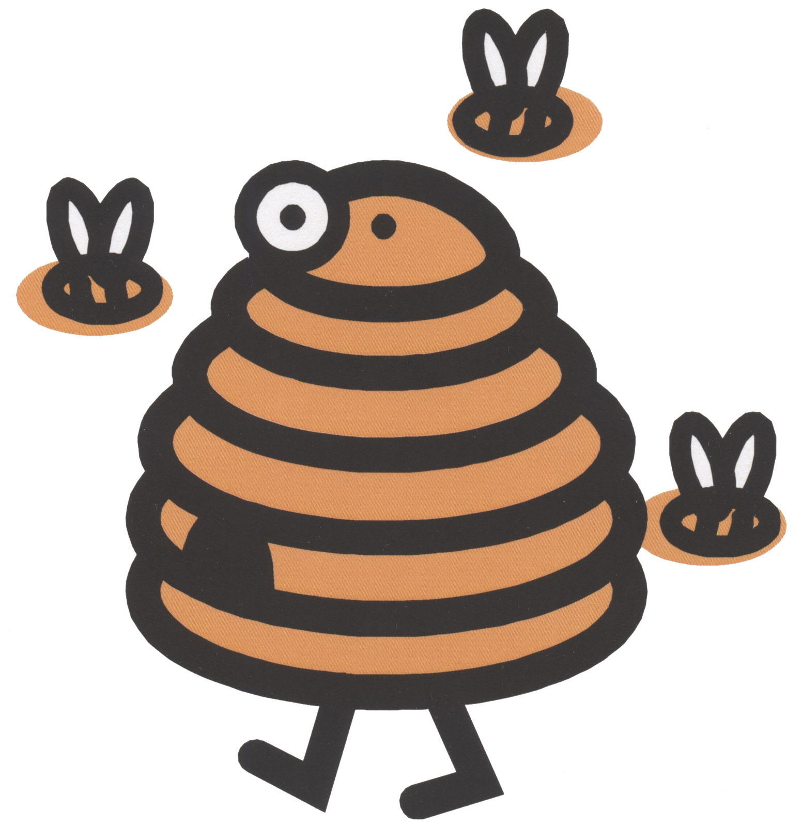
Honey – 116
All Types

Division C -- Wearing Apparel

Division Rules:
A. Garments will be judged on construction, suitability of pattern, fabric, etc.
B. Garments may have been used before being exhibited, but if so, must be carefully laundered and pressed.

Examples Include:

Wearing Apparel
Men’s
Lady’s
Child’s
Other

Decorate Your Duds
Decorative arts include embroidery, appliqué, macramé, painting, etc.

All Types

Division D -- Needlework

Division Rules:
A. Items should be neatly folded for display.
B. Other—means something NOT otherwise listed.
C. All pictures and wall hangings must be mounted and have a wire or secure hook for hanging or they will not be accepted.

Rugs All Types

Quilts Judged on a design or method of construction.
Judged on a quilting design and quilting stitches only.

Quilted Article
All Types

Afghans
All Types

Crocheted Items
All Types

Knitted Items
Al Types

Tatted Items
All Types

Tea Towel
All Types

Pillow Case
All Types
Pillow
All Types

Latch hook
All Types

Potholder
All Types

Placemat
All Types
Needlepoint
All Types

Counted Cross Stitch
All Types

Stuffed Toys
All Types

Doll Clothes - Non-Constructed
All Types

Embroidery
All Types

Crewel Embroidery
All Types

Stitch & Stuff
All Types

Weaving –
All Types

Miscellaneous
All Types

Division E – Horticulture

Division Rules:
A. Vegetables should be washed.
B. Entries must be on paper plates or aluminum-covered cardboard.
C. See extension pamphlet on “Exhibiting Fruits & Vegetables”.
D. All entries must be grown by the exhibitor this year.

Vegetables -
Collective Garden Exhibit—five different fresh vegetables. Only one variety of a specific vegetable may be exhibited. Any combination of small, medium, or large vegetables may be included in the entry. Quality and condition of the vegetables will be considered. The numbers of the five vegetables to be exhibited are as follows:
Large Vegetables—one each: watermelon, squash, pumpkin, eggplant, cabbage, and cantaloupe
Medium Vegetables—five each: cucumbers, tomatoes, carrots, beets, onions, peppers, parsnips, okra, Irish potatoes and sweet potatoes.
Small fresh vegetables- such as green beans are used as one of the five different vegetables; a dozen is suggested for a good display. Shelled vegetables should not be exhibited.
Vegetables-
-Tomatoes, standard garden variety (plate of 5), display bottoms up
-Tomatoes, cherry, grape or plum (plate of 5)
-Potatoes, all types (plate of 5)
-Carrots (plate of 5)
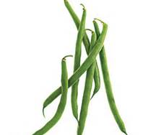
-Peppers (plate of 5)
-Cucumbers (plate of 5)
-Onions (plate of 5)
-Beans (plate of 12)
-Squash (one )
-Pumpkin (one)
-Cabbage (one)
-Eggplant (one)
-Beets (plate of 5)
-Sweet corn with husks (plate of 5)
-Okra (plate of 5)
-Oddly grown
-Fresh Culinary Herbs, 6 stems of ONE VARIETY (not dried)
-Other
Division E – Horticulture continued

Fruits

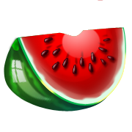
-Watermelon (one)
-Cantaloupe (one)
-Other

-Apples, Apricots, Peaches, Plums, Pears (plate of 5)
Grapes (3 bunches)

Division EE- Horticultue Class EE
The Biggest Contest

-Biggest Tomato
-Biggest Potato
-Biggest Pepper
-Biggest Cucumber
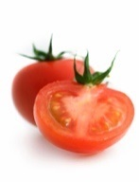
-Biggest Onion
-Biggest Watermelon
-Biggest Pumpkin
-Biggest Cantaloupe
-Biggest Squash
-Biggest Cabbage
-Biggest Eggplant
-Biggest Sunflower Head
-Tallest Sunflower
-Tallest Corn Stalk

Division F– Crops

Division Rules:
A. All entries must be grown by the exhibitor this year.
B. Each entry must be labeled with the name and address of the exhibitor, class number and variety of crops.
C. The wheat exhibit shall be a one-gallon sample in a clear glass jar with a screw-on lid.

--All Types

Division G – Arts & Crafts

Division Rules:
A. All entries must be original works of the exhibitor.
B. Framed pictures need to be ready to be displayed (hangers).
-Metal
-Plastic Canvas
-Stone
-Pastels
-Acrylics
-Oil Portrait
-Water colors
-Colored Chalk
-Crayon
-Painting & chalking
-Ceramics
-Paint by number
-Wall Hanging
-Paper Maché item
-Decoupage
-Charcoal (mounted)
-Pencil portrait (mounted)
-Candles
-Beads (strung)
-Macramé
-String Art
-Stained glass
-China Painting
-Models
-1 bar homemade soap
-Colored Pencil
-Jewelry
-Pen & Ink
-Leather Craft
-Scrap Booking (3 representative pages - no entire books)
-Gourds, Decorated
-3-dimensional paper entries
-Flat paper entries
-Mixed Media (at least 2 different media used)
-Button entries
-Barn Quilt paintings (maximum size 2'x2')
-Coloring book entries (1 page)
-Stick Art (popsicle sticks, matches, pencils, etc)
-Other

Division H - Woodworking

Division Rules:
A. Each exhibitor is limited to one article in each Class.
B. Articles are to be made by exhibitor.
C. Exhibit area for each article is limited to ten square feet of floor space.

-Picture frame
-Woodworking articles for home, farm or shop use
-Lawn and household furniture
-Games or Toys
-Repaired, Refinished or Re-upholstered Furniture
(include a before picture an explanation of refinishing)
-Caning
-Carving
-Other

Division I - Floriculture
Division Rules:
A. Fresh flowers are to be used in all arrangements.
B. Name the variety or species.
C. Exhibitor will furnish all equipment and containers necessary to display their exhibit.

-Garden flowers centerpiece
-Novelty arrangement for sick room
-All white using white flowers and white or clear glass
-Miniature arrangement—5 inches or less
-Centerpiece using vegetables, flowers, or combination of these
-Kitchen arrangement
-Holiday arrangement
-Live Wildflower arrangement

Potted Plants -
-Hanging Planter
-House plant
-Cactus
-Succulent
-Other

Division I – Floriculture continued

Specimens (Suitable Containers)
It is suggested to have foliage with the specimen. Submit a single stalk/stem.
-Aster
-Balsam
-Bells of Ireland
-Cannas
-Cockscomb
-Cosmos
-Dahlia
-Daisy
-Dianthus
-Gaillardia
-Gladiolus
-Lily, Type, Name
-Marigolds
-Petunia
-Phlox
-Rose
-Rudbeckia
-Salvia
-Snapdragons
-Sunflowers
-Verbena
-Vinca, Periwinkle
-Wildflower
-Zinnia
-Hibiscus
-Other Annual
-Other Perennial

Specimens (collection of five different kinds)
All collections

Dried Flowers
-Fall bouquet using grasses, wheat, or dried, local plant materials in their
natural colors in a suitable container
-Arrangement of dried wildflowers
-Arrangement of artificial flowers
-Flowered Swag (dried or artificial)
-Wreath of dried or artificial flowers
-Holiday arrangement
-Other
Division J - Photography

Division Rules:
A. Photographs must be at least 4 x 6 inches BUT NO LARGER THAN 8 x 10 inches. They must be mounted or matted so they don't curl when hung. Maximum size of the mat or mounting board for individual photos is 11 x 12.5". Mats for the group of five 4" x 6" photos may exceed the above maximum size.
B. Framed photographs are not accepted.
C. Group series photos must be matted together on a single mat.
D. The same photo may not be entered in more than one class even if it has been processed differently. (i.e. one in color one in black and white.)
E. The exhibitor’s name must be written on the back of the mount.
F. By entering, all exhibitors agree that, if their photo is selected as the overall Photography Sweepstakes winner, the winning entry will be retained for display in the J.H. Robbins Library. The winning entry may be returned to the winner if the winner provides the sponsor with an 8 x 10 copy by September 1.
G. Multi-page photo books cannot be accepted.
H. Solid-color sepia photos will be considered to be black and white.

Photography

-Black and white photograph
-Color photographs
-Group of 5 related series of pictures
-Picture, special effects
-Conservation Photo-See special rules on next page (pg 19)
Must be 18 years and younger to be eligible

Local Conservation Photo Contest
in conjunction with the Ellsworth County Fair
OPEN CLASS YOUTH Photography Class.

The Ellsworth County Conservation District will sponsor the Best Conservation Photo; Junior Division (Open Class) and provide a $50.00 cash prize for the award at the Ellsworth County Fair. The winning photo will also be entered into Kansas Association of Conservation District (KACD) State Contest with possibility for additional cash prize at KACD Contest.

To participate in the Ellsworth County Conservation Districts Conservation Photo Contest entries must follow all rules as printed in the Ellsworth County Fair book that pertain to youth open class photography.

Subject matter must be CONSERVATION PRACTICES (cover crops, waterways, terraces, pollinators, pest management, wildlife habitat, water quality & soil health) within Ellsworth County.
The winning photograph must be surrendered to the Ellsworth County Conservation District immediately after the fair for submission to the KACD contest. The photographer and a parent will be required to sign a release form for KACD.
- Photos must have been taken between August 1 of the previous year and July 1 of current year.
- Minor digital enhancements for cropping, red eye removal, filters and corrective functions are permitted; but images that have been altered in any significant manner will be disqualified.
- Previously published photos may not be entered.

- Upon surrendering winning photo to the Ellsworth County Conservation District, the photographer must also provide a typed brief description of photo; date and location photo was taken; entrants name, age, address; and the words ELLSWORTH COUNTY and slide this paper into the plastic sleeve with the photo. PHOTO RELEASE FORM (below) must be completed and placed in the plastic sleeve with each photo as well.
- The Conservation District Office is located in the USDA Service Center at 402 W 15th St, Ellsworth.

Division K – Tag-Along Livestock

Division Rules:
A. Exhibitors ages 5 & 6 as of January 1 of the current year are allowed to participate.
B. Exhibitors may use an animal in his/her possession or may use another animal that is to be exhibited in the 4-H Division of the same class, i.e. bucket calf, swine, sheep, goats, and horse.
C. One entry per specie allowed.
D. Classes are showmanship only.
E. Classes are non-competitive.
F. Participants must pre-enter in this division. Pre-entry forms are available at the Extension Office and must be returned no later than July 1.
G. Exhibitors in this division planning to show an animal pre-entered in the 4-H Division must obtain written permission from the owner to be eligible for pre-entry.
H. All animals that will be exhibited in this division (whether in possession of or exhibiting a pre-entered 4-H exhibit of the same class) must be identified and pre-entered in the Tag-Along livestock division. No late entries will be allowed to show.
I. Any animal deemed “wild” will not be allowed to show.
J. Stall space at the barn will be assigned by the Tag-Along Livestock committee.
K. All sick animals will be barred from the Fair. No health requirements other than those listed under each species, except in the event of a sudden disease outbreak in the county.
L. Animals must be in stalls or pens between 9:00 a.m. and 9:00 p.m., except when showing, washing, or feeding.

Bucket Calf –1
Special Rules:
- Calves must be born between January 1 and May 1 of the current year.
- Calves must have been weaned prior to July 15 of the current year.
- Each calf must be broke to lead.
- Calves must stay at the Fair until all exhibits are released.
- Calves should be properly groomed.

Class 1 - Bucket Calf

Tag-Along Livestock continued

Goat – 2
Special Rules:
- Artificial coloring, paint, adhesive, or powder will not be permitted for use on goats during the entire show.
- Communicable Disease/Club Lamb Fungus – All goats will be visually inspected by a veterinarian for sore mouth, infectious skin lesions (ringworm) and general health. This will be done as you check in your goat. All blankets must be completely removed from all goats at check-in. Any goat found to be infected with active fungal lesions, or other health problems, must be removed from the premises. Any goat may be required to undergo a second health inspection at the Superintendent’s request.
- Bracing: Goats cannot be braced and must be shown with all four feet on the ground. Animals must be shown with a chain or collar used only to control the animal. Exhibitors may use collars, collars with a short lead or halters when showing. No extreme collars (spike/training) will be allowed. Exhibitors can only briefly touch their animal with their body and cannot use the chain/collar to make their animal tense their muscles.
- Teeth: All wethers must have baby teeth in place with no visible signs of permanent teeth. The decision of the mouther is final.
- Shearing: All wethers must be “slick shorn” with an equal amount of hair above the knee and hock before arrival on the grounds. A maximum of 0.4 (four tenths) inch of hair is permitted. Hair on the tail switch is permitted.
- Horns: Wethers are suggested to be dehorned. However, if horns are left, they should be tipped and rounded.

Class 2 - Goat

Swine –3
Special Rules:
- All swine must be free of parasites.
- Sick hogs will be barred from the show.

Class 3 - Hog

Tag-Along Livestock continued

Horse – 4
Special Rules:
- Horses will be brought in only for the day of judging, with the 4-H horse show.
- The horse’s name must be listed on the pre-entry form.

Class 4A - Walk-Trot Showmanship
Class 4B - Walk-Trot Horsemanship

Sheep – 5
Special Rules:
- No artificial coloring will be allowed on the lamb except on the hooves.
- Market lambs must have been slick shorn prior to check-in with equal length of wool over the entire body.
- Animals must be checked for club-lamb fungus at check-in, before being allowed in the barn.
- Any intact male or female sheep must have scrapies tag present before they may be exhibited at the Fair.

Class 5 - Sheep

Rabbits –6
Follow 4-H Rabbits rules

Class 6 - Rabbits

Poultry-7
Follow 4-H Poultry rules

Class 7 - Poultry

Division L -- Ag/Industrial Technology
1. Projects dealing with shop & farm mechanics or technology may be entered.
2. Project Considerations:
A. Creativity - novelty & originality
B. Significance - cultural importance of the design
C. Complexity - significance & technical sophistication
D. Feasibility - degree of being easily or conveniently done
3. Projects shall be judged on the basis of:
A. Construction & workmanship
B. Materials & finish
C. Practical value and use (functionality)

Division Rules:
1. Projects should be geared toward student mechanics projects.
2. Items cannot exceed 20 foot in length (IE, large trailer).
3. Contest space is limited. When display area is full, no more entries will be accepted.
Mechanics
Special Rules
All items must be rebuilt or refurbished by the entering individual.
No company auto body or welding work done by corporation will be accepted.
Metal fabrication
Welding, wrought iron, metal machining, sheet metal, metal casting, forging, etc.
Small engines
Special Rules:
2 or 4 cylinder engines are acceptable.
Items cannot exceed the size of a 4-wheeler (NO car, truck, or larger engines)

Electrical
Special Rules:
Items may not exceed a 3-foot by 3-foot display area.

Small Shop Projects
Special Rules:
Items cannot exceed $250 in building costs

Large Shop Projects
Special Rules:
Includes items $251 and above in building costs. Example: a trailer
Items cannot exceed 20 feet in length.

Sample Entry Form (This was used for previous entry for open class. Hopefully we have an easier plan for 23) STAY TUNED
PICK UP YOUR ENTRY NUMBER WHEN YOU REGISTER

Exhibitor Number _________ Age _____ Age _____ Exhibitor Number _______
(Only if Junior) (Only if Junior)

Name ______________________________ Name ________________________________________________
Division ____________Class No__________ Division_________________________ Class No.______________

Class Name __________________________ Class Name ____________________________________________
Ribbon Sticker here
Blue White Blue White
Purple Red Participated Purple Red Participated

A sample open class entry tag is shown above. To help in your registration, please complete both halves of the entry tag according to the division you are entering in the Open Class Fair. It is important to write out the class name.

Senior Division entry tags are LEMON.
Junior Division entry tags are GREEN.

***THIS IS A SAMPLE***
The Division, Class No., and Class Name will be according to each individual entry.
Livestock Judging Contest

Open to ALL ages.
- Arrive at fairground and sign in 15 minutes before the contest begins.
- Contestants will judge four classes of livestock. May include: market steers, breeding heifers, market lambs, breeding ewes, market hogs, breeding gilts, market goats or breeding meat goats. Data may be included on a breeding class.
- Age divisions as of January 1:
  - Senior 14-19 years old (1 set of oral reasons and 1 set of questions)
  - Intermediate 10-13 years old (1 set of oral reasons)
  - Junior 9 years and under (1 set of questions)
  - Adults 20 years and over (placings only)

